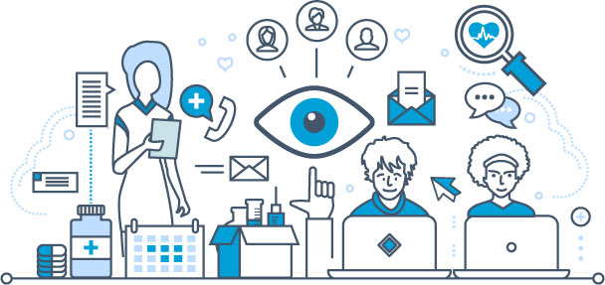
How we keep your personal data safe and secure.
AGED 13 YEARS OR OVER?

These days, we’re all aware of how important it is to keep our personal data safe and secure. If you are aged 13 years or older then you can ask us who is allowed or not allowed to know about the care you have been given by us or the NHS. This might be about illnesses you’ve had or medicines provided by a hospital or doctor. You can ask us how we should get in touch with you, ask what is on yourpersonalmedical files, decide who’s allowed to view your medical files and ask us to stop some of the ways we use your info.

PLEASE VISIT OUR WEBSITE TO VIEW OUR PRIVACY NOTICE OR ask about our ‘13-or-over’patient privacy LEAFLET, so you know how to:
- ask for a copy ofyour medical information that we have on our computers;
- ask that we update, complete or fixany information that is incorrect;
- ask that we delete information or stop others seeing your private medical records;
- ask that we send your information over the internet to another care provider;
- stopNHS departments orothers viewing or using your information – e.g. for research into curing or preventing illness, seeing which medicines workbest or so the government can plan how much money they spend on everyone’s healthcare.

Complaints
If you have any concerns about how your personal information is managed by usplease ask our reception how to contact our Data Protection Officer. If you are unhappy after we’ve looked into your request you can then complain directly to an organisation called the ICO(Information Commissioners Office):
Website:www.ico.org.ukEmail:casework@ico.org.ukTel: 0303 1231113 (local rate) or 01625 545745

